PARENTS OF VISION IMPAIRED NZ (INC)
Annual Report
2026
For the year ended 30 June 2026

Contents

Year at a glance 3
About PVI 4
From the Chair 5
Operations Report 7
Financial Summary 10
Financial Statements 12
Notes to the Financial Statements 15
Independent Assurance Practitioner's Review Report 20

Our whakataukī

Kia hora te marino, kia whakapapa pounamu te moana, kia tere te kārohirohi i mua i tō huarahi.
May peace be widespread, may the sea glisten like greenstone, and may the shimmer of light guide you on your way.

Contact us
Postal address: PO Box 5629, Frankton, Hamilton 3242
Phone: 0222 6215740
Email: rgraham@pvi.org.nz
Website: www.pvi.org.nz
Facebook: www.facebook.com/pvinz

Year at a glance
A snapshot of what Parents of Vision Impaired NZ (PVI) achieved for families in the year ended 30 June 2026.
$250,752  Total revenue, up 21% on 2025 | $28,928  Surplus for the year (2025: deficit of $15,306) | $136,764  Net assets at 30 June 2026 | $162,172  Cash and short-term deposits
29  Submissions made to Select Committees, councils and inquiries | 6  Zoom workshops for parents and whānau | 2  Editions of eVision (December and April) | 4  Board meetings held

Highlights
- Standing up for our families. PVI was active in opposing the Disability Support Services (DSS) Bill and in organising a coordinated sector response.
- Our voice in decision-making. We made 9 submissions to Select Committees on Bills, 5 submissions to local councils, and 15 responses to inquiries, reviews, surveys and consultations. In each submission, PVI centred the needs of children with vision loss and their parents and whānau.
- Connection and support. Our part-time staff member and Zoom workshops kept parents connected, and our Facebook group and email list continued to grow steadily.
- Conference and whānau wānanga. We held our 2025 Conference and AGM, planned the 2026 Conference and AGM, and planned and funded a noho-based whānau wānanga for whānau Māori.
- Global connections. Dr Rebekah Graham represented PVI and New Zealand at the Global Leadership Exchange 2026 in Canada in June.
- Strong partnerships. We strengthened our partnership with Kāpō Māori Aotearoa and continue to work closely with Blind Low Vision NZ and BLENNZ.
- A sound financial position. PVI finished the year with a surplus, no debt, and an unmodified review conclusion from BDO Wellington Audit Limited.

About PVI
Parents of Vision Impaired NZ is a parent-led incorporated society and registered charity (Charities Commission number CC# 20913). Our governing body is made up entirely of volunteers.

Our mission
To provide a community of support for parents and whānau of a vision-impaired person.

Our purpose
- To empower parents and whānau to support their blind, deafblind, and vision-impaired children.
- To improve the health, welfare, education, and social opportunities of vision-impaired children.
- To benefit the children and whānau of vision-impaired children within New Zealand.
- To promote, develop and maintain a nationwide support network.
- To promote and provide ongoing communication for parents and parent support groups of vision-impaired children.
- To foster communication and co-ordination of services between PVI, agencies and other community groups.
- To be proactive in all areas and concerns related to vision-impaired children and their whānau.
- To be beneficial to the wider community.

Our values
Whanaungatanga | We establish and maintain positive relationships
Manaakitanga | We care for and support each other
Kotahitanga | We work together to achieve greatness
Moemoeā | We have aspirations for ourselves, our children, and our community

How we are funded
Our main sources of funds are Blind Low Vision NZ, lotteries, grants, and donations. PVI applies for grants from various organisations. We also receive in-kind administrative support from Blind Low Vision NZ.

From the Chair
Tēnā koutou katoa,
It has been a privilege to serve as Chairperson this year, and I am honoured to have taken on a new role within the PVI whānau. I am grateful for the support, knowledge and experience I have gained along the way.
Welcome and thanks. I warmly welcome our board members for 2026, and extend a special welcome to Ian Brooke and Alex Maddox, who began their first official terms this year. We are privileged to embrace their lived experience, expertise and perspectives.
Thank you to every board member for sharing your time, experience and wisdom. Thank you to Rosemary Cox, our parent liaison, for her enthusiasm and warmth, and for facilitating our online Zoom workshops. Thank you also to Dr Rebekah Graham for her determination and courage as our Executive Officer.
Looking back. The 2025 conference was a highlight, with our parent stories and William’s session for dads especially memorable. The AGM on the Saturday ran smoothly, and the change of day was well received. We have gathered and reflected on the feedback from the conference, which has helped us to improve future events.
We also strengthened our partnership and collaboration with Kāpō Māori Aotearoa (KMA). I acknowledge CEO Chrissie Cowan, who was awarded an ONZM (Officer of the New Zealand Order of Merit).
Strategic direction. We continued to review and revise our Strategic Plan for 2025–2030, having updated our organisational values at the July 2026 board meeting. Our focus has been on making the plan more cohesive, robust and accountable, and progress has been steady.
Advocacy: the Disability Support Services Bill. Much of our energy this year has gone into responding to the rapid progress of the Disability Support Services (DSS) Bill. I extend a massive thank you to everyone who contributed, and to William McGrath for delivering PVI’s oral submission. The Bill has cast a long shadow, and I hope we will continue to work together to find the best way forward.
International representation. Dr Rebekah Graham was accepted into the GLE Global Leadership Exchange 2026 and represented PVI and New Zealand in Canada in June. This was a significant opportunity for PVI, and it has opened doors to strengthen our relationships with existing consumer groups, build new networks globally, and bring new knowledge back to our whānau.
Supporting parents and whānau
- Online Zoom workshops, facilitated by Rosemary Cox, continued throughout the year.
- Pamphlets with PVI information continued to be distributed within our regions.
- We continued to strengthen our relationships with fellow consumer groups and to foster new connections.
Learnings from the NZ Federation of Disability Information Conference (May). I attended this conference on behalf of PVI and want to share a few key takeaways:
- Music therapy. Kimberley Wade of Southern Music Therapy spoke about how music therapy builds brain connections linked to language, movement and memory. Music and movement, particularly vestibular movement, can activate and strengthen the sensory cortex, including for vision.
- AI and digital tools. Whaikaha and several presenters strongly encouraged the use of AI and digital delivery in the disability sector. I believe the board would benefit from educating ourselves on these tools so we are proactive and can better support our parent network. Erika Butters (Volition), Karrina Mountford and Alex Kemp can speak to new apps being trialled as well as existing AI software.
- Community resource. Chris Davis shared a book, available in the Canterbury region, that supports people with disabilities. I would like us to explore starting a similar conversation for PVI’s vision-impaired community, including a visually accessible resource listing all consumer groups in New Zealand and their purposes.
- Caregiver training. The Federation is developing training for caregivers with a special focus on self-care.
A closing word on self-care. Self-care is central to everything we do. As the saying goes, self-care is not self-indulgence, it is self-preservation. When you say yes to others, make sure you are not saying no to yourself. I encourage all of us to give ourselves permission to pause.
I believe that by drawing on each other’s strengths as a team, we will continue to fulfil the mission of PVI: “Supporting and empowering parents and whānau.”
Ngā mihi nui,

Stacey Dodd
Chairperson

Operations Report

What did PVI do this past year?

1. Governance
- Held the 2025 AGM, with 3 Board members duly elected.
- Held 4 Board meetings (28 July, 8 October, 7 March, 29 April).

2. Support and advocacy
Advocacy and support provided directly to PVI families in the following ways:
- Emails of support written for parents.
- Advice given on responding to exclusion and discrimination.
- Employed one part-time staff member to connect with parents and organise local events.
- Information shared on a variety of relevant topics.
- Individual interactions with parents via email, telephone and direct messages.
- Held 6 Zoom workshops on a variety of topics.
- Held (and paid residual costs for) our 2025 Conference and AGM.
- Planned (and paid deposits for) our 2026 Conference and AGM.
- Planned and paid for a noho-based whānau wānanga for Māori whānau.

3. Applied for funding
Successful funding was sourced as follows:
Blind Low Vision Operational Grant | $180,000
NZ Lotteries and COGS | $17,650
External contracts | $11,500
Whaikaha Community Development Grant | $6,200
ANZEF Research Grant | $2,500
Donations | $900

4. Systems-level advocacy
PVI made submissions on Bills and to Select Committees (9), local councils (5), and various inquiries, reviews, surveys and consultations (15). In every submission PVI centres the needs of blind, deafblind, low vision and vision-impaired children and young people, and their parents and whānau. Doing so ensures that decision-makers are aware of, and have in mind, the needs of our families when creating and implementing policies and laws.
PVI is often the only group advocating on behalf of children with vision loss. PVI was active in opposing the DSS Bill and in organising a coordinated sector response.

5. Publications, communications and promotion
PVI disseminated information, promoted PVI, and informed our members by:
- Keeping our membership database up to date.
- Producing and delivering two editions of eVision (December and April).
- Delivering regular monthly email newsletters.
- Maintaining our website, keeping it up to date, and producing several blog posts.
- Maintaining a regular posting schedule on our Facebook page.
- Using our Facebook group and page to connect parents and provide support and information.
- Maintaining the PVI website as a key site for information, linked to eVision and email newsletters.
- Ongoing engagement with BLENNZ and Blind Low Vision NZ.
- Contributing to academic publications.

6. Collaborative working
PVI supported a representative to attend or contribute to the following workstreams and events:
- Access Matters Aotearoa
- Carer Support Working Group
- Child Poverty Action Group
- Eye Health National Clinical Network – Childhood Workstream
- Fairer Futures Coalition
- Federation of Disability Information Centres Annual Conference
- Finding Common Ground hui and workshop
- Kāpō Māori Aotearoa Hui Taumata
- Māori and Pasifika Eye Health Data Working Group
- Matike Mai Accessible Resource Rōpū
- Whaikaha Parent/Family/Whānau Network
We also continued to collaborate with Kāpō Māori Aotearoa on international and national conference presentations and research.

How well did PVI do it, and is anyone better off?
Focus area | How well did PVI do it? | Is anyone better off?
Governance | The 2025 AGM ran smoothly. The PVI Board upskilled and continues to provide good governance. | Yes. PVI continues to be well governed by a functional and competent Board.
Support and advocacy | Members feel connected, supported and empowered. | Yes. Parents are supported and empowered to advocate for their child as a result of their conversations and communications with PVI.
Funding | Funding was secured for projects and to enable the continuation of PVI. | Yes. Funding means PVI can continue to support parents, run the organisation, disseminate information, provide online workshops, and subsidise our annual parent conference.
Systems-level advocacy | Submissions were made and information provided for national and regional level systems. | Yes. The needs of PVI families are regularly kept before decision-makers at a national and regional level.
Communications | Information was disseminated to parents in a timely and accessible fashion. Electronic communications led to increased engagement with parent members and increased promotion of PVI. Membership of our Facebook group, a core online site for parents to ask questions, interact and share information, has increased. | Yes. Effective communication means parents are kept informed. Connections across the membership have increased, contributing to a sense of belonging. Facebook group membership and the email list continue to grow steadily.
Collaborative working | Collaborative working relationships developed and grew across networks and topics. | Yes. We are stronger together. Working collaboratively means PVI can continue to have national, long-term impact.

Financial Summary
PVI NZ finished the year in a stronger position than it started. The figures below are taken from the performance report for the year ended 30 June 2026, which was reviewed by BDO Wellington Audit Limited.
Key figures | 2026 | 2025 | Change
Total revenue | $250,752 | $207,094 | +$43,658
Total expenses | $221,824 | $222,400 | –$576
Surplus / (deficit) for the year | $28,928 | ($15,306) | +$44,234
Cash and short-term deposits | $162,172 | $131,093 | +$31,079
Total liabilities | $31,000 | $31,259 | –$259
Net assets (total accumulated funds) | $136,764 | $108,803 | +$27,961

Revenue
Total revenue rose by 21% to $250,752. Blind Low Vision NZ remained our largest source of funding at $180,000, up from $164,500. Grants increased to $41,024 from $26,500, and other revenue doubled to $28,828.
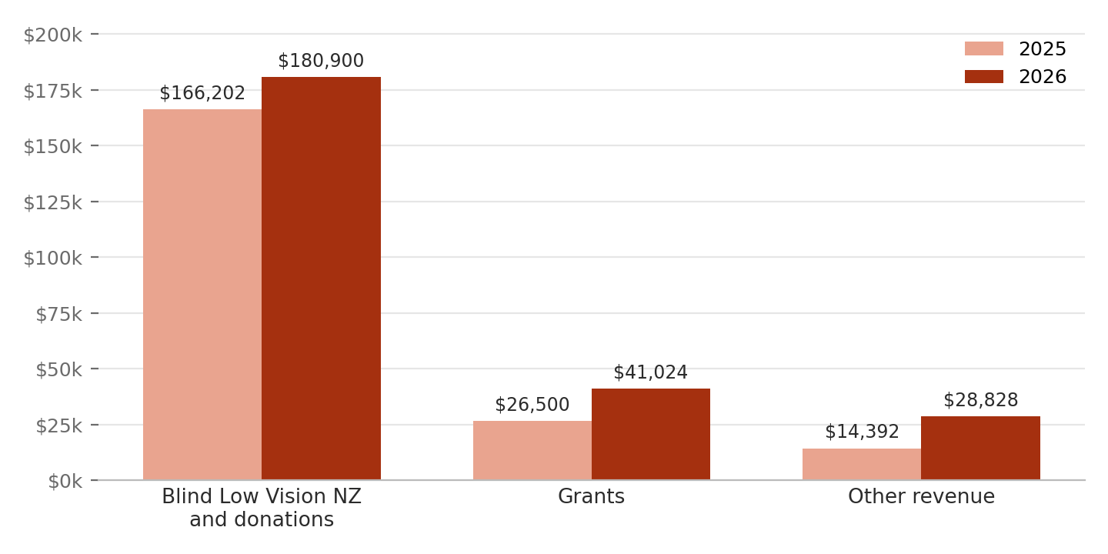

Expenses
Total expenses of $221,824 were almost the same as last year ($222,400), but the mix changed. Employee costs rose to $132,531 from $113,237, including international staff travel of $16,205 (nil last year) and local travel of $4,750. Conference expenses fell to $53,160 from $69,813.
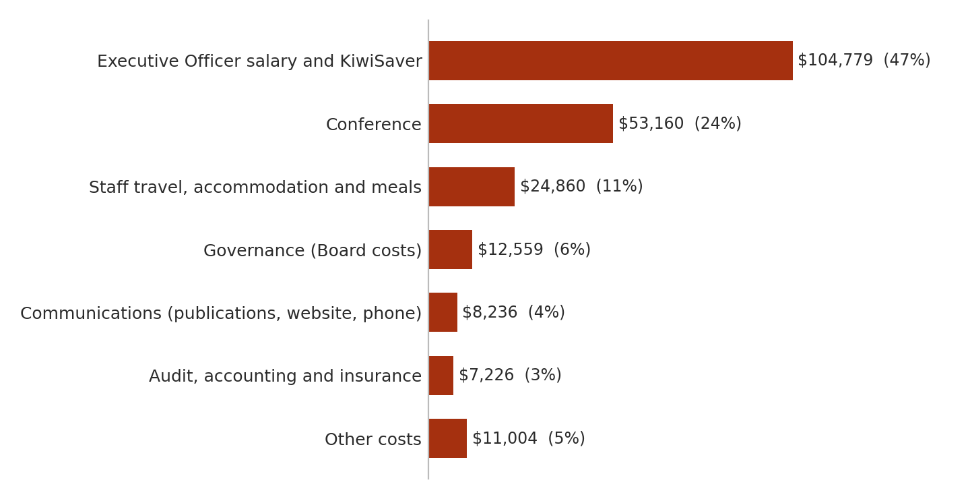
Expenses are grouped from Note 2 of the financial statements.

Financial position
PVI ended the year with net assets of $136,764, up from $108,803. Of this, $51,379 is held as operating reserves. All liabilities ($31,000) are current, such as creditors and income received in advance, and PVI has no debt, commitments or contingencies at balance date.
The performance report is prepared on the basis that PVI will continue to operate for the foreseeable future. BDO identified no issues or concerns that would mean that assumption cannot be relied upon.

Financial Statements
Parents of Vision Impaired (NZ) Inc – for the year ended 30 June 2026

Statement of Financial Performance
 | Note | 2026 ($) | 2025 ($)
Revenue
Donations, koha, bequests and other general fundraising | 1 | 180,900 | 166,202
Grants |  | 41,024 | 26,500
Other revenue |  | 28,828 | 14,392
Total revenue |  | 250,752 | 207,094
Expenses
Employee remuneration and other related expenses | 2 | 132,531 | 113,237
Expenses related to commercial activities | 2 | 86,685 | 108,986
Grants and donations made | 2 | – | 390
Other expenses | 2 | 2,608 | (213)
Total expenses (cost of providing services) |  | 221,824 | 222,400
Surplus / (deficit) for the year |  | 28,928 | (15,306)

Statement of Financial Position
As at 30 June 2026
 | Note | 2026 ($) | 2025 ($)
Current assets
Cash and short-term deposits | 3 | 162,172 | 131,093
Debtors and prepayments | 3 | 4,979 | 7,765
Total current assets |  | 167,151 | 138,858
Non-current assets
Property, plant and equipment | 4 | 613 | 1,204
Total assets |  | 167,764 | 140,062
Current liabilities
Creditors and accrued expenses | 3 | 19,614 | 23,988
Deferred revenue | 3 | 4,204 | 4,740
Other current liabilities |  | 7,182 | 2,531
Total liabilities |  | 31,000 | 31,259
Net assets (total assets less total liabilities) |  | 136,764 | 108,803
Accumulated funds
Accumulated surpluses or (deficits) | 5 | 85,385 | 56,457
Operating reserves | 5 | 51,379 | 52,346
Total accumulated funds |  | 136,764 | 108,803

Approval
This performance report has been approved by the Chairperson, Executive Officer and Treasurer, for and on behalf of Parents of Vision Impaired (NZ) Inc.
  Chairperson  Stacey Dodd  Date: 30 September 2026 |   Executive Officer  Rebekah Graham  Date: 30 September 2026 | 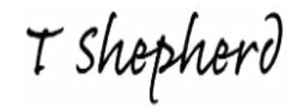  Treasurer  Tirzah Shepherd  Date: 30 September 2026

Statement of Cash Flows
 | 2026 ($) | 2025 ($)
Cash flows from operating activities
Donations, fundraising and other similar revenue | 180,900 | 166,202
Grants | 41,024 | 26,500
Other revenue | 28,876 | 14,392
Employee remuneration and other related payments | 131,809 | 113,237
Expenses related to commercial activities | 86,685 | 78,924
Grants and donations paid | – | 1,065
Net cash flows from operating activities | 32,306 | 13,868
Cash flows from other activities
Cash payments | 1,227 | –
Net cash flows from other activities | 1,227 | –
Net increase / (decrease) in cash | 31,079 | 13,868
Opening cash | 131,093 | 154,653
Closing cash | 162,172 | 168,521
Represented by bank accounts and cash | 162,172 | 131,093

Notes to the Financial Statements

Statement of Accounting Policies
- Basis of preparation. PVI NZ has elected to apply PBE SFR-A (NFP) Public Benefit Entity Simple Format Reporting – Accrual (Not-For-Profit), as it does not have public accountability and has total annual expenses of $2,000,000 or less. All transactions are reported on the accrual basis, on the assumption that PVI NZ will continue to operate in the foreseeable future. The New Zealand dollar is the reporting currency.
- GST. All amounts are recorded exclusive of GST, except debtors and creditors, which are stated inclusive of GST.
- Bank accounts and cash comprise cash balances and bank balances (including short-term deposits) with original maturities of 90 days or less.
- Grants and operational funding are recognised as revenue when the conditions of the grant agreement have been met. Where there is no use or return condition, the grant is recognised as income when received. Grants for which the requirements have not been met at balance date are shown as income in advance under current liabilities.
- Donations. Miscellaneous donations, recoveries and registrations are recognised as revenue when received.
- Fixed assets and intangibles are recorded at cost and depreciated or amortised on a diminishing value basis over their estimated useful lives.
- Liabilities. General liabilities, other than provisions, are recognised when the goods and services to which they relate are received. Creditors are carried at the amount of cash required to settle the liability.
- Changes in accounting policies. There were no changes in accounting policies during the year.
- Commitments and contingencies. There were no commitments or contingencies at balance date (last year: nil).
- Related party transactions. PVI NZ continues to receive in-kind support from Blind Low Vision NZ for administrative services (value calculated as $0). Allowances are paid to Committee members for incidental costs incurred in attending meetings.
Depreciation rates (diminishing value):
Computers and software | 48%
Printers | 39.6%
Furniture and fittings | 20%
Motor vehicles | 26%
Website | 50%

Note 1: Analysis of revenue
 | 2026 ($) | 2025 ($)
Blind Low Vision NZ | 180,000 | 164,500
Donations | 900 | 1,702
Total | 180,900 | 166,202

Note 2: Analysis of expenses
Employee remuneration and other related expenses | 2026 ($) | 2025 ($)
Executive Officer salary | 101,903 | 103,026
KiwiSaver employer contributions | 2,876 | 3,091
Staff expenses | 358 | 1,337
Staff training and development | 2,054 | 272
Staff travel – local | 4,750 | 1,625
Staff travel – international | 16,205 | –
Staff gift | 480 | –
Staff accommodation and meals | 3,905 | 3,886
Total | 132,531 | 113,237

Expenses related to commercial activities | 2026 ($) | 2025 ($)
Accountancy fees | 1,016 | 851
ACC levies | – | (61)
Audit fees | 4,770 | 6,135
Bank fees and charges | 271 | 75
IRD penalties | – | –
Bad debts expense | – | –
Board – food and beverage | 338 | 3,653
Board – travel | 4,210 | 6,469
Board – accommodation and room hire | 6,878 | 4,685
Board – training and resources | 700 | –
Board – general expense | 433 | 54
Computer expenses | 833 | 408
Conference expenses | 53,160 | 69,813
Consultancy | – | –
Direct funding costs | – | 120
Freight and courier | – | –
General expenses | – | –
Insurance | 1,440 | 1,435
Meetings | 243 | –
Membership / subscription fees | 400 | 1,338
Office expense | 1,363 | 377
Postage | 270 | 414
Printing and stationery | 1,533 | 1,114
Publications and newsletter | 5,900 | 8,850
Rent | – | –
Telephone, tolls and internet | 2,201 | 1,639
Depreciation | 591 | 1,367
Website | 135 | 250
Total | 86,685 | 108,986

Grants and donations made | 2026 ($) | 2025 ($)
Donations and koha | – | 390
Grants paid to other organisations / persons | – | –
Total | – | 390

Other expenses | 2026 ($) | 2025 ($)
Events | 2,120 | (213)
Research expense | 488 | –
Total | 2,608 | (213)

Note 3: Analysis of assets and liabilities
Bank accounts and cash | 2026 ($) | 2025 ($)
ANZ Bank Account – Cheque | 140,707 | 110,408
ANZ Bank Account – Society Cheque | 21,465 | 20,685
Total | 162,172 | 131,093

Debtors and prepayments | 2026 ($) | 2025 ($)
Prepayment – Conference FY2027 | 4,979 | –
Prepayment – Conference FY2026 | 0 | 6,348
Accounts receivable | – | 1,417
Total | 4,979 | 7,765

Income in advance | 2026 ($) | 2025 ($)
Conference fees 2027 | 4,204 | 0
Conference fees 2026 | – | 4,740
Total | 4,204 | 4,740

Trade and other payables | 2026 ($) | 2025 ($)
Review fees | –
Accruals | 6,235 | 6,247
Credit card payable | 789 | 1,601
Blind Low Vision NZ | 12,470 | 11,748
Weave Together | 120
Access Matters Aotearoa Trust | – | 999
V24 Limited | – | 3,393
Total | 19,614 | 23,988

Note 4: Property, plant and equipment
2026 ($) | Opening | Purchases | Disposals | Depreciation | Closing
Computers | 935 | – | – | 411 | 524
Mobile phone | 269 | – | – | 180 | 89
Total | 1,204 | – | – | 591 | 613

2025 ($) | Opening | Purchases | Disposals | Depreciation | Closing
Computers (including software) | 1,757 | – | – | 822 | 935
Mobile phone | 813 | – | – | 544 | 269
Total | 2,570 | – | – | 1,366 | 1,204

Note 5: Accumulated funds
2026 | Accumulated surpluses ($) | Reserves ($) | Total ($)
Opening balance | 56,457 | 52,346 | 108,803
Surplus / (deficit) | 28,928 | (967) | 27,961
Closing balance | 85,385 | 51,379 | 136,764

2025 | Accumulated surpluses ($) | Reserves ($) | Total ($)
Opening balance | 71,763 | 53,020 | 124,783
Surplus / (deficit) | (15,306) | (674) | (15,980)
Closing balance | 56,457 | 52,346 | 108,803

Independent Assurance Practitioner's Review Report
Report on the Parents of Vision Impaired performance report, by BDO Wellington Audit Limited.

What this report is
BDO Wellington Audit Limited reviewed PVI’s performance report for the year ended 30 June 2026. This review mainly involves making enquiries of management and others within the entity, and applying analytical procedures.

Responsibilities
- The Trustee is responsible for identifying and reporting relevant, reliable, comparable and understandable outcomes and outputs, for preparing and fairly presenting the performance report in accordance with PBE SFR-A (NFP), and for the internal control needed to prepare a report free from material misstatement, whether due to fraud or error.
- BDO is responsible for expressing a conclusion on the performance report, in accordance with ISRE (NZ) 2400 and ISAE (NZ) 3000 (Revised). Other than as assurance practitioner, BDO has no relationship with, or interests in, PVI.

Conclusion
Based on our review, nothing has come to our attention that causes us to believe that:
- the reported outcomes and outputs, and quantification of the outputs to the extent practicable, are not suitable; or
- the performance report does not present fairly, in all material respects, the financial position of Parents of the Vision Impaired as at 30 June 2026, and its financial performance and cash flows for the year then ended; and the entity information and its service performance for the year then ended, in accordance with Public Benefit Entity Simple Format Reporting – Accrual (Not-For-Profit).

BDO WELLINGTON AUDIT LIMITED
Wellington, New Zealand
30 September 2026

